HCI Design Report

**Introduction and analysis**

For our topic we decided to chose the Recycling App - game based game. Our brief was to design an app which would help people understand recycling and help increase the amount recycled by the user. We chose the game/app as we feel we have the sufficient tools and knowledge to create a helpful and informative app that would reward users for recycling and could create competition across all age groups.

This document will cover the design process as a whole that was used while creating the predefined application on recycling.

The first method used was to use stakeholders, stakeholders are any group or person with an interest in the matter at hand[1], in this case our stakeholders were groups that would be interested in the recycling application. Stakeholders were used to help us maximize joint positive outcomes for both our group and the stakeholders. Some stakeholders used were charities and non-profit, environmental groups and recycle plants. All these companies would benefit directly from increased recycling as non-profits would not need as much donations to fight pollution and more jobs would be created at recycling plants etc.

For the characteristics of the location, we need to pay attention to the common user and how they will use this app . This app must be able to run on all phones with access to an app store. We want to minimise load times between scenes so that the user has an enhanced experience and is not waiting on assets loading into the scene. For our game, we must retrieve stats from the leaderboards, one from global and one from local. We must load this data constantly onto the game so that the user is not retrieving long lists of data when they go to check how high up the list their friends are. When the user has pressed a button, the button must execute without fail and take them to the required scene that they intended to go to.

We created a list of personas that we felt were most valuable for testing the system. We identified their background and what goals they hope to achieve for the state of our current ecosystem. We identified their particular characteristics and what their overall knowledge of new technology was. We also identified their specific conditions (eg colour blind, learning difficulties). These personas helped us created a profile for our recycling app and helped us focus on specific users needs instead of just getting fixated on the general user[2].

A number of scenarios were created until one was chosen as the main scenario to use. A scenario is a description of a persona’s interaction with/within a system. Scenarios can help the design team focus on specific user requirements. Scenarios are often used to help design teams see system interaction from the user’s perspective. They are useful for finding and solving usability constraints within a system or application[3]. We ended up deciding on using a scenario where a middle aged male wants to teach his children to recycle as this applies to both the primary user groups the application is designed to target. Some of the problems we chose to target were to make sure the game would not be overly complex as it is aimed at both adults and children, as an extension of this the game should be easy to pick-up and learn. The solution was to make navigation of the game clear and simple and make sure all buttons were easy to read with clear text. The use of scenarios helped greatly in the design process as it pointed out some potential problems we could encounter and helped us solve them before they appeared.

Requirements were used in the design process. Requirements analysis is used to provide the design team with a checklist of requirements and provide a contract between the project sponsors and the developers[4]. In our case, requirements analysis was used to help visualise the final product and make sure no stakeholders were being overlooked for any needs they may have from the application. We also made sure the requirements fit what was needed from the scenario created. After the list was created, we rated the requirements from low priority to high priority. Some of the high priority requirements included that the application must be simple to use, the application must have been finished by a certain date and that the application must make reference to recycling. These were all set to high as without these requirements the application created would not fit the design specification. The ordered list of requirements helped overall in the design process as it helped keep everything on track and helped us make certain nothing was being forgotten or overlooked by the design team.

To take our user on a journey through our system, we created an information flow chart and a use case diagram. These diagrams are key requirement methods and helped us identify key relationships between the player and the system. Use case diagrams give textual descriptions of functionality of the system from a user's perspective and how they will interact with the system[5]. It clearly shows the relationships between the different use cases and the users and how users will use the different functionality that is involved. We started with the actor (player) on the left hand side. The actor then connects to the different use cases that are present in our system such as playing mini-games, getting xp, customizing character etc. These use cases are connected via relationships in the form of arrows in our diagram. The direction of the arrow shows the relationship process. The information flow diagram shows how the data and information is communicated from one point to another. This information can flow back and forth and shows the iterative process in how certain aspects of data are retrieved and stored. The actor is stored at the top our our diagram, in this case we identified this as our Start Game button. The information flow is the line from one class to another. Once data can be transferred back from one class to another, it is shown on the diagram.

A wireframe of the main navigation interface was created, a wireframe is a non-graphical visual guide that represents the skeletal framework of a website or application[6]. We used a wireframe to get a grasp on the functionality of our application and how the user interface would work. Our wireframe ended up being quite simple as the overall design of the application was being kept as simplistic and easy to use. The wireframe was still able to help in getting a definite layout of our main navigation interface and it helped us design the further navigational aspects of the application and the information such as where to place buttons and art etc. We were also able to check if the interface was user friendly and functional.

.

**User Centered Design**

Today, many ways to approach design and development exist. Different approaches contain different methods and focuses but all are designed to help designers understand how to design products and be aware of other needs and capabilities other than their own. There is no clear best way to approach design and development as every approach has merits and demerits and are best suited for their specific situation. The approach looked at in this review will be user centered design. “The most important aspect of the design process is to provide the user with the real usage context.” Such is the claim made by Eeva Kangas and Timo Kinnunen, authors of the paper *User-Centered Design to Mobile Application Development.* This is something, I believe, User Centered Design carries this out very well.

How does user centered design help? One of the ways user centered design helps the design stage is that it helps designers answer questions such as “What does the user really need?” And “What skills and abilities do the users have?”. This is found out by using several different methods such as focus groups and user profiling. Once these questions have been answered however they help the designers keep goals and targets. It also helps to keep the designer and user connected as what the designer considers most important might not be what the user finds most important[7].

User centered design is an iterative process. An iterative process is a process which will arrive at its completed result after repeated analysis and changes[8]. An iterative process will, ideally, become closer to the end goal with each iteration. User centered design being an iterative process helps as it further connects the designers and developers to the users to keep the users at the center of the design process, which is one of the main ideas behind UCD (We will use UCD instead of user centered design from here on). The fact that UCD is iterative also helps with identifying bugs and problems and allows the users and stakeholders to see the identified bugs and problems being fixed and removed.

One of the main principles behind UCD is mainly to focus on the user and users needs. This helps immensely as it makes it extremely difficult to make a product/application which the user will not like or will be unable to use. Carrying out task analysis and collecting data on the task environment is also useful as it shows how users are influenced by their physical environment and how users previous knowledge or experiences influence how they perform tasks etc[9]. Carrying out early testing and evaluation is another principle of UCD, this is used as it would be illogical to get the users’ views near the end of the process if the product is meant to be based on user input and reviews.

The methods used in UCD are all strongly linked with the user as the designers must understand what the user has asked for before starting the next iteration of the product. Techniques used include user profiling, focus groups and paper prototyping. These all collect heavily on user feedback to ensure the designers have the information necessary to move onto the next iteration of the product. It also ensures that the next iteration of the product will be an improvement in the eyes of the majority of users, leading to happier users overall and a product with increased usability.

Several methods are used by designers to ensure the users are kept in the loop throughout the whole design process. One way they ensure the user has a direct input is by obtaining feedback from users. This feedback can be anything from how the users feel about the design to how easy or difficult it was to use the system. This supplies both designers and developers with information they can use later in the process. Another method is to provide users with prototypes, depending on the user feedback the product may be redesigned to fit the user's needs[10].

Involving users in the design process as done in UCD is helpful as it gives the designers and developers access to excellent information and in general, the product will tend to be more effective. The users may also feel a sense of ownership in the product as they has a direct input throughout the entire process which is a definite advantage to UCD.

Contrary to this, UCD is not a perfect design process. This is evident as products will tend to take much more time to create and user-centric design can end up being expensive due to the multiple prototypes and iterations that are required. It can also be difficult to carry some types of data into the design process[11].

In conclusion, UCD helps answer many questions about the user that can be difficult to obtain a direct answer to and helps make a good final product by using user feedback and input. In my opinion UCD is an incredibly helpful way of designing a product as it feels that the product will almost always be successful in the end even if the process might end up more expensive overall.

**Response to feedback**

From our storyboard feedback, a local theme to our app was missing. Originally we had one leaderboard (later called global leaderboard) that displayed a certain number of users points from across the world. Given the feedback, we decided to add a local leaderboard to the leaderboards menu. This leaderboard displays the points of users in your area with this app and displays how far away they are (eg TheJ1M 10m away). This local leaderboard can give bragging rights to users in a friends group or area, and they can be known as the best recycler.

**Prototype**

Below are some screenshots from some scenes of our prototype.

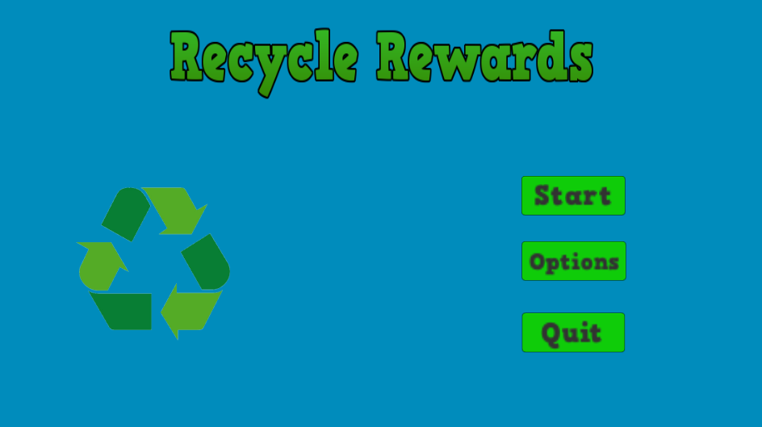

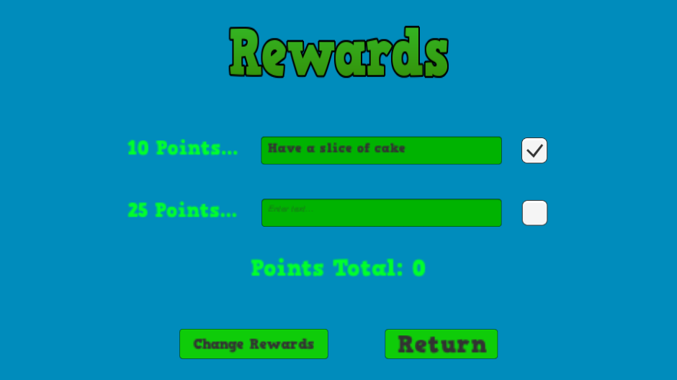

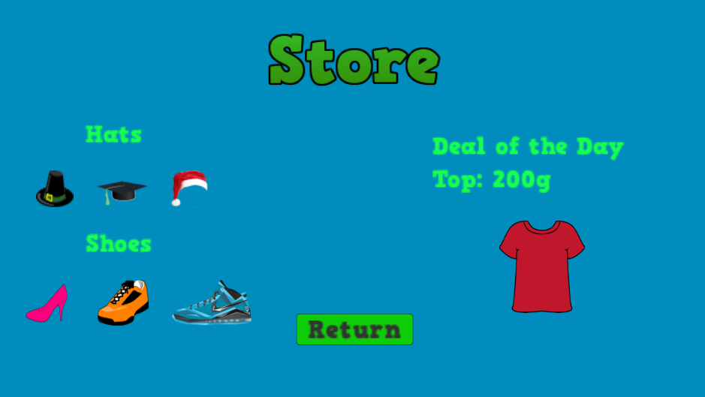

For the design of the prototype, we decided to use the main colour of the game/app as green. This colour goes well with the theme of recycling as most people associate the colour green with the recycling theme. The colour green is also associated with peacefulness, balance and harmony[12]. We used a blue colour for the background as it helps the buttons and text in green stand out more and it doesn’t overpower the colour feeling and helps blend it all together. The colour blue symbolizes wisdom, confidence, intelligence, trust and strength[13].Using these colours together gives the user a wide variety of emotions when first loading up the game. This causes them to feel natural with the game and it welcomes their underlying emotions.

For the layout of the buttons, we tried to keep them as consistent as possible. Each buttons text has the same style across all scenes in the game to avoid any confusion. If a scene has the same number of buttons, they will all be in the exact same position as the last set of buttons. The buttons will accept user input when pressed. This matches with our original requirement that was high priority on the list in that the system must handle user input. The button has very minimal text on it so understanding what the button does and where it takes you is very simple for all ages (children and adults). This was another one of our high functionality requirements that we feel we have achieved.

All age groups understanding how the buttons work isn’t the only thing that they need to understand. Our main mechanic of our game is to recycle, then set your own rewards via the different scenes in our game. We had to keep the scene where you input your own rewards to be simple. Once users insert their own rewards, they can then click the checkbox next to the input box. This will then deduct points from the user's total and the user can enjoy their own reward. This input box also checks off another one of our high priority functionality in that the application must be able to encourage users to recycle. These points can be used for a lot of different things in game and can have many different purposes. Getting points all stems from recycling so in turn this encourages the user to get these points and help promote the purpose of the specification of our game.

**Sources**

[1]-<http://www.businessdictionary.com/definition/stakeholder.html>

[2]-<http://www.usability.gov/how-to-and-tools/methods/personas.html>

[3]-<http://infodesign.com.au/usabilityresources/scenarios/>

[4]-<http://www.sciencebuddies.org/engineering-design-process/design-requirements-examples.shtm>

[5]-<https://sourcemaking.com/uml/modeling-it-systems/external-view/the-elements-of-view/use-case-diagram>

[6]-<https://en.wikipedia.org/wiki/Website_wireframe>

[7]-User-Centered Systems Design: A Brief. History - Springer

[8]-<http://www.businessdictionary.com/definition/iterative-process.html>

[9]-<http://www.usability.gov/how-to-and-tools/methods/task-analysis.html>

[10]-Lecture 2 Slides

[11]-<http://www.slideshare.net/shalinishingari/user-centered-design>

[12]-<http://www.empower-yourself-with-color-psychology.com/color-green.html>

[13]-<http://psychology.about.com/od/sensationandperception/a/color_blue.htm>